**Becoming an “all-round” media person in the new era**

Source: People's Forum

Author: Zhang Meng

Editor: Zhang Yao

2021-11-24

https://www.rmlt.com.cn/2021/1124/632536.shtml

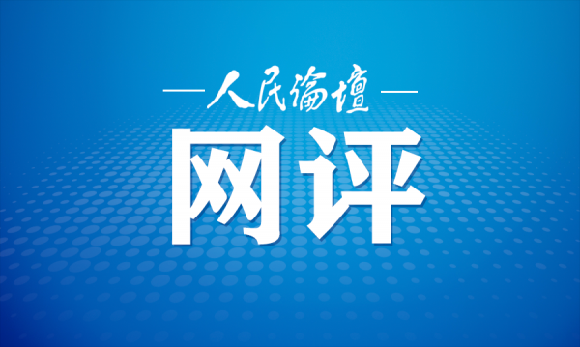

Recently, President Xi Jinping sent a congratulatory letter to the Fourth World Media Summit. He stressed that the media has an important social responsibility to correctly answer the issues of the times and build a broad consensus around the world. He hoped that the guests at the summit would have in-depth discussions and enhance consensus around the theme of the summit, strive to be the communicators of people-to-people exchanges and the promoters of cultural exchanges, and make due contributions to promoting the common values ​​of all mankind and building a community with a shared future for mankind. In the era of self-media, media professionals should constantly enhance their abilities of "listening", "speaking", "reading" and "writing", and play a "combination punch" of "listening", "speaking", "reading" and "writing" to become "all-round" players in the new era.

**"Listen" and understand the voice of the people.** The Sixth Plenary Session of the 19th Central Committee of the Communist Party of China summarized "upholding the supremacy of the people" as one of the ten historical experiences of the Party's century-long struggle. "Listening to the voice of the people" is the basic way to inherit the century-old historical experience of "upholding the supremacy of the people", and it is also a compulsory course for media people in the new era. "Listening to the voice of the people" should not be limited to the action of "listening", but should achieve the result of "understanding". Because "listening" is the basis for accepting advice, only by opening up the channels of speech can we hear the real opinions and the real people's livelihood. "Listening" is a behavior that media people must have, and understanding is a way to understand the people's sentiments and gather public opinion. Nowadays, people can speak anytime and anywhere through media such as Weibo and WeChat. How to summarize and classify the sentiments and opinions of the people from massive information is a test for media people, so "understanding" is a capability that media people must have. The people are the creators of history and the "fertile soil" for the development of political parties and the country. No matter how small the people's affairs are, they are also major events. In the new era, media professionals must collect and organize public sentiment and opinions from open platforms such as "private messages", "backstage messages", and "forwarded comments" to provide data support for the formulation of national policies.

**"Speak" clearly about the Chinese solution.** The media is a society's "microphone", and people understand society through the media. "Yao had a drum for remonstration, and Shun had a tree for slander", and the ancients knew how to play the role of public opinion. During the revolutionary war years, Mao Zedong emphasized that revolution depends on "two sticks", namely the pen and the gun. Propaganda and ideological work are extremely important for national development, social stability, and people's education. General Secretary Xi Jinping emphasized that "where the readers are, where the audience is, where the tentacles of propaganda and reporting should be extended, and where the focus and foothold of propaganda and ideological work should be placed." In the new era, media people must enhance their professional qualities, establish a correct professional outlook, and do a good job in propaganda and ideological work with a Marxist view of journalism. They must consciously use mainstream values ​​and mainstream ideologies to publicize the policies of our party and our country, spread positive energy, send out China's voice, tell China's stories well, and explain China's solution clearly, so that people can understand the policies and guidelines of our party and our country from the "words" of the media, and know the people and things with positive energy in society, so that the world can understand our party's governing philosophy through the "voice" of the media, and feel the responsibility and selfless contribution of our party and our country.

**"Read" the world situation.** The world is undergoing a major change that has not been seen in a century, and the major change is accelerating. Faced with a complex and ever-changing world situation, media professionals in the new era must have the ability to "read" the world situation. This ability does not mean the ability to simply read books and newspapers, nor the ability to read ten lines at a glance and remember everything when reading newspapers. Instead, it means the ability to see the essence through phenomena from the practice of exchanges between countries and from the documents of international organizations, to "read" the world situation, to understand the substantive issues behind the surface behavior, and to "know" the world situation. At present, the world has long been a "global village" with a common destiny. As the distance is closer, cultural exchanges are becoming more frequent. The integration of cultures into "you in me and me in you" is the trend of world development. If media professionals want to "read" the world situation, they must maintain strategic determination and a clear mind in cultural exchanges, and with a higher political stance and stronger political literacy, resist the "invasion" and "assimilation" of cultures that do not conform to the socialist values ​​with Chinese characteristics. At the same time, with the vision of "the country's big things" and the mind of "embracing all rivers and seas", they must respect cultural diversity, let diverse cultures produce more sparks in the collision, widely build world consensus, make correct and sonorous voices, and draw "concentric circles" of countries around the world.

**"Write" a good answer sheet of the times.** The media shoulders the important social responsibility of widely gathering world consensus and correctly answering the issues of the times. In the past 100 years, our party has handed in a satisfactory "answer sheet" to the people. Carrying on the past and forging ahead, media people must also answer the "answer sheet" of the new era on the new road to the exam. "The trend is what we should take advantage of, and the time that cannot be lost is also." Media people should plan, act and follow the trend according to the trend, firmly grasp the general trend, do a good job in ideological propaganda, and let the broad masses of people gather their ideals, beliefs, values ​​and moral concepts like "pomegranate seeds" tightly, let Marxist theory penetrate into the minds of the broad masses of people, and become Marxists in the new era. In the context of the interweaving of the century-old changes and the century-old epidemic, and the profound and complex evolution of the international pattern, the media should play a good role in building consensus, and media people should adhere to objectivity and truthfulness, uphold the principle of seeking truth from facts, and use a high level of scientific and rational judgment to be responsible public information communicators who oppose rumors and prejudices. We must uphold a sincere and trusting attitude and responsibility, seek common ground while reserving differences, and integrate common ground and differences around the world, "write" a good answer to the times for media professionals, be determined to be communicators of people-to-people bonds and promoters of cultural exchanges, and be determined to do a good job in reporting to enhance the well-being of people in all countries, and spare no effort and forge ahead to promote the common values ​​of all mankind and promote the building of a global community with a shared future for development.